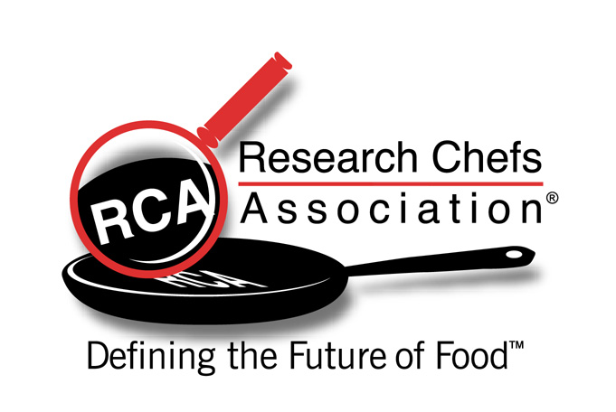

For Immediate Release Contact: Anneliese Doyle (404) 252-3663

Research Chefs Honor Memory of Michele Block
RCA Initiates the Michele Block Memorial Scholarship Fund

ATLANTA (March 20, 2006)— The Research Chefs Association (RCA) proudly announced the founding of the Michele Block Memorial Scholarship Fund, a fund created to honor the many contributions of Michele Block, during its Annual Conference this year in Houston.

Block was a long-time member of the RCA and sat on the Board of Directors as the Associate representative for several years. Her dedication to building the organization’s successful sponsorship program, as well as helping to plan several Annual Conferences, has significantly advanced RCA’s mission and contributed immeasurably to its many accomplishments. She served as Darifair Foods’ Vice President of Marketing in Jacksonville, Florida, and is greatly missed by friends and family.

RCA President John Folse unveiled the new Memorial Scholarship Fund on March 9 in Houston, at RCA’s Annual Conference. The RCA presented a $10,000 check to the Research Chefs Foundation to initiate the Fund, and Darifair Foods generously matched this donation. Total contributions, including additional donations collected during the Conference’s Opening Reception, totaled nearly $25,000. Beginning in 2007, the Research Chefs Foundation plans to award an annual scholarship with monies provided by the Michele Block Memorial Scholarship Fund.

The Research Chefs Foundation, a 501(c)(3) corporation, was founded in 2002 to help achieve the RCA mission: Defining the future of food® through Culinology® and the development of its practitioners. The Foundation provides financial assistance in the form of scholarships to qualified students and professionals pursuing higher learning and continuing education in Culinology, Culinary Arts, and Food Science. The Foundation is proud to make educational opportunities possible for a greater number of students and food industry professionals who are committed to Culinology.

###

Founded in 1996, the RCA has rapidly grown to approximately 2,000 members, including chefs, food scientists, technologists, writers, nutritionists, academicians, researchers, consultants, sales and marketing professionals, suppliers, co-packers, distributors and students. RCA is the premier source of culinary and technical information for the food industry, and is committed to the advancement of Culinology® –the blending of the culinary arts and food science. For more information, please visit the RCA Web site at www.culinology.org.

